**Capital Structure**

**Cost of Capital**

# Cost of Capital

* Refers to the **required return** on an investment by an Investor
* If the expected return on an investment is SMALLER than the required return, then the investor will NOT invest in that particular asset
  + **Cost of Equity** → Required Return on **Equity Investments**
  + **Cost of Debt** → Required Return on **Debt Investments**
* From a Corporate Finance perspectives, firms **raise money through investments** - Cost of Capital helps them gauge how well the firm must perform to be able to raise money

## Cost of Equity

* It is equivalent to the required return under the CAPM formula



## Cost of Debt

* 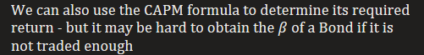
  + 
  + Credit Ratings are **inversely proportional** to the probability of Default
  + 
  + 
* 
  + 
  + 
  + 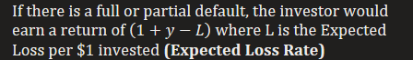



# Required Return on Projects

* Company Managers need to determine the required return on project in order to analyse it
* The money raised by the firm through various rounds will be used to fund these projects - but since they cannot be mapped to those sources of finances, the above methods cannot be directly used
* Instead, we use the properties of **Comparable Firms** to determine the required return
  + They are firms that are engaged in the **same type of business** and **similar levels of risk** that the project is taking on

## All Equity Financed Project (Unlevered Equity)





If the firm is levered, then we use the **Unlevered Cost of Capital** Instead,





We can determine the weights of the two uses the **MARKET VALUE of Debt and Equity**







## Equity & Debt Financed Project (Levered Equity)

* Debt is tax deductible - Firms who use Debt pay less tax, thus there is a benefit to using Debt
* If the project uses Debt, then the cost of Debt should **reflect this Corporate Tax benefit**



Similar to before, since the firm uses both Equity and Debt, we use the **Weighted Average Cost of Capital**.



Note that the WACC and Unlevered Cost of Capital are related:







Note that the Cost of Capital on **Unlevered Equity** is known as the **Pre-Tax WACC** while the Cost of Capital on **Levered Equity** is known as **Post-Tax WACC** - Unless otherwise stated, WACC on its own usually refers to the **post-tax WACC**

## Multiple Securities

* So far we have only assumed that there are two kinds of assets used - Debt & Equity
* This can be further broken down into various sub-methods, as discussed in the previous chapter
* Each of these methods have their own unique Cost of Capital, thus the overall Cost of Capital is the **weighted average of all Cost of Capitals for all securities**

# Enterprise Value

* It is the total value of the company defined in terms of its financing
* It represents the actual cost of purchasing a company



* When a company is purchased, the entire company, including its Debt is purchased
* The cash inherited is used to pay off this debt, thus we subtract cash & only consider the **Net Debt**

Using the Enterprise Value, we can obtain weights for the company:











Debt and Cash are often considered to have the same risk,







**MM Propositions without Taxes**

# Key Assumption: Perfect Capital Markets

* **Perfectly Competitive** → All parties can trade the same set of securities at their competitive prices (PV of all their future cashflows)
* **Frictionless → No taxes** and no transaction costs related to trading
* **Independence** → Financing and Investments decisions are independent of one another

# Proposition 1 without Taxes

* The value of a firm is equal to the market value of its assets & is **NOT affected by its capital structure**
* The Value of an Unlevered Firm and otherwise equal Levered firm are the **SAME**
* Capital Structure merely affects the split between Debt & Equity with **NO effect on the overall value**



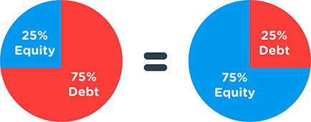

## Homemade Leverage

* Every Investor has a different risk appetite - some prefer more leveraged investments etc
* **Homemade Leverage** suggests that **regardless of the capital structure** of the firm, the investor can achieve their desired risk of their portfolio **through borrowing or lending themselves**
* Since all investors can borrow and earn at the **same rate as the firm**, homemade leverage is a perfect substitute for leverage used by the firm



* An investor wishes to purchase a certain amount of stock - owning part of the company
* Since the investor owns part of the company now, they also **own part of the Debt**, based on the CURRENT capital structure of the firm
* 



* This changes the capital structure of the part of the firm that he earns
* Based on MM proposition 1, this still leaves the value of the part of the firm that he bought **unchanged**









# Proposition 2 without Taxes

* Cost of Levered Equity **increases linearly** with the firms Debt to Equity Ratio
* Note the distinction in terminology:
  + 
  + 
* Since the value of a Levered an Unlevered firm are the same, their **Cost of Capital are equal**





















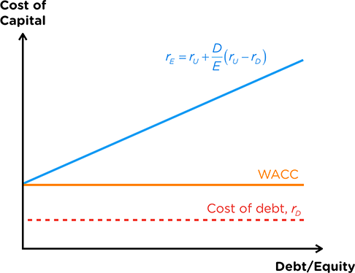

### Risk & Capital Structure

* The risk of a project is unaffected by its capital structure - regardless of how the money is sourced, the money will still be used in the same way resulting in the **same risk**
* Conversely, this means that the risk of the firm or project **DOES NOT** affect the Cost of Capital
* Only the risk of financing affects the Cost of Capital:
  + Debt Financing is **Less risky** as it has a priority claim on Assets → All else equal, the **Cost of Debt should be lower** than that of Equity
  + Equity Financing **increases in risk** as more debt is taken on → **Increases linearly** with Debt
  + However, the Increasing Cost of Equity is offset by the proportion of Equity, thus the overall **WACC remains unchanged**

### Exam Technicalities

* The textbook for IFM defines the problem slightly differently, but the overall idea is the same
* 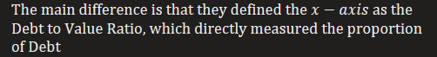
  + Cost of Equity now increases **exponentially**
  + Cost of Debt **now increases** at high Debt to Value levels

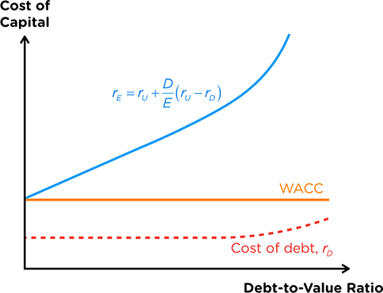

**MM Propositions with Taxes**

# Assumption Change

* We relax one of the assumptions to **allow for Corporate Taxes** to be present
* As mentioned previously, Debt is **Tax Deductible**, which creates an **Interest Tax Shield** for firms



|  |
| --- |
| **Balance Sheet** |
| Revenue |
| (Operating Expense) |
| **Operating Profit (EBIT)** |
| (Interest Expense) |
| **Taxable Income** |
| (Tax Expense) |
| **Net Income** |

Note that Interest payments **reduce the taxable income** hence generates a *shield from tax*

# Proposition 1 with Taxes

* Value of a Levered Firm is greater than that of an otherwise equivalent Unlevered Firm by an amount equal to the **PV of Interest Tax Shield**
* Value of a firm **IS** affected by **Capital Structure** - Maximize value with a **100% Debt Financing**



Note that we can compute the value of the firm directly by discounting the **Free Cashflow** of the firm as a **growing Geometric Perpetuity:**





## Non-Permanent Debt

* Most Debts have a limited maturity, which means that Interest Payments only occur for a set period
* This forms a **stream of constant equal payments** from the valuation date **till Maturity**
* We can use the Annuity Formula to calculate the **PV of the Interest Tax Shield** at the **Cost of Debt**





## Permanent Debt

* If the company chooses not to pay off the principal of the Debt, interest payments will **continue forever**
* This forms a **stream of constant equal payments forever**
* We can use the Perpetuity formula to calculate the **PV of the Interest Tax Shield** at the **Cost of Debt**





Simplifying it further,





## Entire Firm

* The above two cases are for calculating the interest tax shield generated by a specific debt
* If we are required to find the Interest Tax Shield for the firm, then this method is preferred:
  + Calculate the amount of Debt in the firm by using the DE ratio
  + Calculate the Interest Payments by multiplying by the Cost of Debt
  + Calculate the Interest Tax Shield by multiplying by the Corporate Tax Rate
  + Assume the Tax Shield grows at the same rate as the firm
* Use the Geometric Perpetuity formula to calculate the PV of the interest Tax Shield, **discounted at the Unlevered Cost of Equity**
  + Reason is because the Interest Tax Shield has similar risk to the underlying firm
  + But since the tax shield itself does not benefit from tax deductions, we should not account for it
* This method implicitly assumes that the **DE ratio of the firm remains constant**



# Proposition 2 with Taxes

* Arrives at a **similar result** to the case **without taxes** - the Cost of Equity still increases linearly with the firms DE ratio
* However, due to the presence of the Tax Deductions, the **decrease in Cost of Debt is larger than the increase in Cost of Equity**, thus the **WACC decreases with the DE ratio**





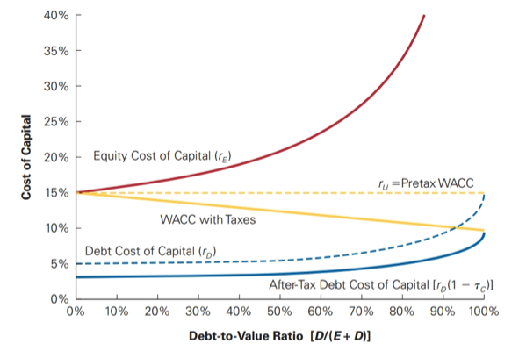

Note that the **Pre-Tax WACC remains unchanged** as it is not affected by the tax rate

**Value Reducing Effects**

# Financial Distress Costs

* Although Debt generates an interest tax shield, it also creates an **obligation to repay**
* If the firm **defaults** on any of its repayments, the Debtholders have the **right to claim the firm's assets** through the **Legal Bankruptcy** process
* Equity Financing may sometimes pay Dividends but are **NOT** obligated to do so - **NO Financial Distress**

## Bankruptcy Costs

* **Chapter 7 Bankruptcy** → Firms assets are liquidated through an Auction & proceeds are used to repay the Debtholders
* **Chapter 11 Reorganization** → Existing management is given a chance to reorganize the company, with a specific plan to repay each of the creditors
  + **Workout** → Company negotiates with firm directly without filing for chapter 11
  + **Prepack** → Company creates a plan ahead of time then files for chapter 11
* Note that these costs are ONLY incurred in the **event of a Default**

|  |  |
| --- | --- |
| **Direct Costs** | **Indirect Costs** |
| Loss of **3-4%** of Firm Value | Loss of **10-20%** of Firm Value |
| Fees to **hire professionals** to aid the Bankruptcy process:   * Legal, Accounting, Consultants etc * Firms with **complicated operations** tend to have **higher direct costs**     These **costs are fixed** thus tend to **affect small firms more** | Intangible costs that affect **business operations**   * Loss of Customers & Receivables * Loss of Suppliers & Employees * Fire Sale of Assets     These costs **may even occur before bankruptcy** if potential is high |

ONLY costs that arise from the Bankruptcy Process are considered Bankruptcy Costs

NOT all loss in value is due to Bankruptcy

## Losers during Bankruptcy

* Debtholders account for the possibility that the firm may default on its debt
* Thus, they often pay less or require higher yields to account for the loss of value - the exact amount deducted is the **PV of Financial Distress Costs**
* This is affected by 4 main factors:
  + **Capital Structure** → Using more Debt have a **higher chance** of distress
  + **Cashflow Volatility →** More volatile cashflows **have higher chance** of distress
  + **Type of Assets** → Intangible Assets are **harder to sell**, resulting in **higher PV** of distress cost
  + 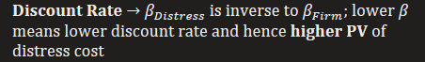

# Agency Costs

* Costs that arise due to **conflict of interests** between the various **stakeholders** of the company - Management, Shareholders & Debtholders
* It typically revolves around **unequal sharing of Costs or Benefits**
* There is an **inherent agency cost** due to management acting as an Agent for key stakeholders
  + **Empire Building** → Management prefers projects that **increase the size** of the firm rather than profitability as it would benefit them more
  + **Entrenchment** → Management is **unlikely to get fired** thus they take on projects that suit them rather than stakeholders

## Agency Costs of Leverage

* When a firm uses leverage, there is an inherent **conflict of interest** if the decisions made have **different implications for Share and Debtholders**, which is likely the case **when financial distress is high**
  + **Asset Substitution →** Shareholders **prefer high risk investments** due to the possibility of higher returns while **Debtholders prefer less risky ones** since their returns are fixed
  + **Debt Overhang →** Shareholders get paid last and may not reap the benefits of new projects, thus are **NOT willing to finance** new projects **which could help Debtholders**
  + **Cashing Out →** Shareholders prefer to **quickly liquidate assets** and distribute it as dividends to cash out of the firm which **worsens the position of Debtholders**

Shareholders will be willing to finance a new project if it generates an NPV greater than the **Debt Overhang**:



* 
* Notice that if the company has no Debt, then any positive NPV project will be taken

### Reducing Agency Costs

* **Short Term Debt** → **Reduces opportunity** for shareholders to make decisions that harm Debtholders but increases the firm's risk of financial distress
* **Debt Covenants** → Places **restrictions** on the actions of the firm but limits the firm's ability to take on potentially beneficial projects

### Who bears the Agency Costs of Leverage?

|  |  |
| --- | --- |
| **Unlevered Firm** | **Levered Firm** |
| Debtholders **pay less for Debt** as they anticipate Agency Costs | Firms risk increases; **decreasing value of existing debt** |
| Borne by Equity Holders | Borne by Debtholders |

### Leverage Ratchet Effect

* Equity holders have an **incentive to take on additional debt** at the expense of the firm value
* Since the cost of new debt is not borne by them, they can simply take on **additional leverage at no cost -** the raised capital can even be used to **pay out dividends**
* They will not reduce the leverage as it would be more expensive compared to when it was raised

## Agency Benefits of Leverage

* However, if the company takes on Leverage, Management could provide **agency benefits instead**
  + **Ownership Concentration** → Management often has **Equity stake**; using leverage increases their ownership and thus they have **incentive to do what is best for the firm**
  + **Free Cashflow Hypothesis** → Leverage reduces Free Cashflow, forcing them to use funds efficiently thus **reducing unnecessary spending**
  + **Increased Commitment** → Leverage **increases the chance managers get fired** thus they are more likely to do what is best for the firm

# Asymmetric Information Costs

* Managers have more information about the firm than investors, leading to **Asymmetric Information**
  + **Adverse Selection** → Seller (with **more information**) likely to sell **lower quality goods**
  + **Lemons Principle** → Buyer **lowers the price** they are willing to pay due to Adverse Selection
  + Both concepts are two sides of the same coin (Buyer VS Seller perspective)

## Overcoming Asymmetry Costs

* Sellers can use the **Credibility Principle** to convince buyers not to lower their price
* Sellers must take actions that buyers assume they would otherwise be unwilling to take if their sales pitch was untrue ("**Actions Speak Louder than Words**")
* Thus, investors will monitor the actions of management to gain insights into the firm:
  + **Equity Financing** → Believe stock is Overvalued → Negative Signal
  + **Debt Financing** → Confident in Cashflow Generation → Positive Signal
* Managers know they are being scrutinized, thus abide by the **Pecking Order Hypothesis** - prefer financing methods that sent positive rather than negative signals
  + Retained Earnings > Debt Financing > Equity Financing

## Effects on Equity Issuance

* Investors know that equity is only issued when the stock price is over-valued → Investors will not be willing to buy the stock and hence the **price declines when Equity is issued**
* Managers intending to issue Equity will want the price to be as high as possible → Release primarily good news and hence **price rises prior to an Equity Issuance**
* The reason that prices fall is because investors think that the stock is overvalued due to **Asymmetric information →** Effect is minimized when the Asymmetry is **minimized right after an earnings announcement**

**MM Proposition with Value Reducing Effects**

# Trade Off Theory

* Balances the Value Enhancing and Value-Reducing effects of Debt on a firms capital structure
  + **Value Enhancing →** Interest Tax Shield & Agency Benefits
  + **Value Reducing →** Financial Distress Costs & Agency Costs
  + Different types of firms are affected by these factors differently

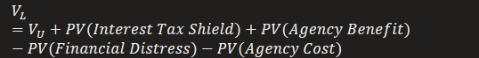

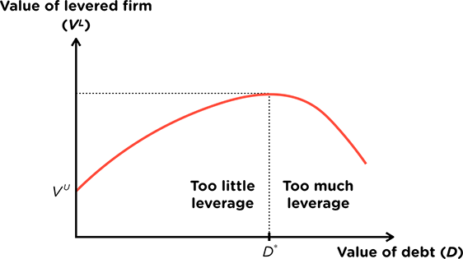

# Optimal Debt

* Initially, the value enhancing effects outweigh the value reducing effects, increasing firm value
* But as more Debt is added, the value reducing effects take over, reducing firm value
* The **Optimal Debt Level** is when the value of the firm is **maximized**
  + 
  + **Marginal** increases and decreases in firm value **perfectly offset each other**

## Optimal Debt in Practice

* Firms often do not end up choosing the optimal level of Debt based on trade off theory
* Managers often choose a **lower level of debt than optimal** since using too much Debt may cause financial distress & hence job loss, which would require them to be **too disciplined**
* However, managers often increase Debt in response to a Takeover Threat or Shareholder Activism
  + They often increase Debt PAST the optimal point to introduce more risk and lower the value of the firm to discourage these actions

# Key Summary

* **Without Taxes & Without Value Reducing Effects** → NO optimal capital structure
* **With Taxes & Without Value Reducing Effects** → Optimal capital structure is 100% Debt
* **With Taxes & With Value Reducing Effects** → Optimal capital structure when firm value is maximised